**CS506 Interim Report**

Submitted on: 03/20/2018

**Department of Defense 1033 Program Analysis**

**Prepared by:**

Joseph O’Donnell

Gautham Ravichandran

Albert Sze

Eric Iren Zhang

### Introduction:

The topic pursued in this analysis is in regard to the use of the Department of Defense (DOD) 1033 program by local law enforcement agencies (LEAs) and how that relates to the demographics of the people protected by those agencies. The initial analysis will be regarding Massachusetts but future analysis will be expanded to look for broader trends nationwide. The preliminary analysis is done on Massachusetts to ensure that code is working correctly and to more rapidly change how future analysis will be performed. Methods for Massachusetts will be scaled to other states in future analysis.

### Questions:

The specific questions being considered are:

1. What are statistical characteristics of a town/municipality or police department that receives a larger than the average amount of weapons? What towns are they?
2. Does education, race, income, or voting pattern have an impact on the types of donations received by a law enforcement agency?
3. Looking at major public safety events in recent history (school shootings, major protests, September 11th, etc.), is there a correlation with the occurrence of an event and donations received immediately following? If there’s a positive correlation, how soon after the incident does it happen, and how long does it last, on average? (how long does it take to return to pre-event levels)
4. Student Question - Is there a similarity between which town demographics in different states drive the acquisition of equipment? Is there a trend between different regions of the United States?

### Datasets:

There are two primary datasets needed for this analysis. The first is the 1033 program dataset which lists, for each LEA, what equipment was obtained when, and what that equipment is worth. This dataset is fully obtained and augmented through the use of the Google Maps API to obtain GPS coordinates for each LEA which allows for geographic grouping and rapid visualization of geographic location of the LEAs.

The second dataset is US census data for each state from 2016. The data for Massachusetts has been obtained and the other states are available but not yet downloaded. The US census site had various parameters for the state broken down by town and county. The 1033 program dataset has a list of LEA by town and so the census data was used to tie each LEA to its town’s features respectively. The key features that the initial exploratory analysis looked at includes HS completion rate, poverty rate, population density based on town size and housing units, and racial breakdown of each town.

### Initial Analysis:

Preliminary analysis for question 1 and 2 was done by first gathering the census data for each LEA. Furthermore, each LEAs’ purchased unit count, average unit cost, and median purchase amount was calculated using the 1033 dataset. For this initial dive, individual weapon/equipment type was not taken into account; the data was looked at holistically. As part of the initial analysis, each town’s various census attributes were plotted against both average unit cost and median purchase amount. In this way, any visually striking patterns between the two variables can be identified.

Interestingly, LEAs located in towns with a lower population density, spent more money on DOD equipment, when compared to LEAs located in towns with higher population densities.

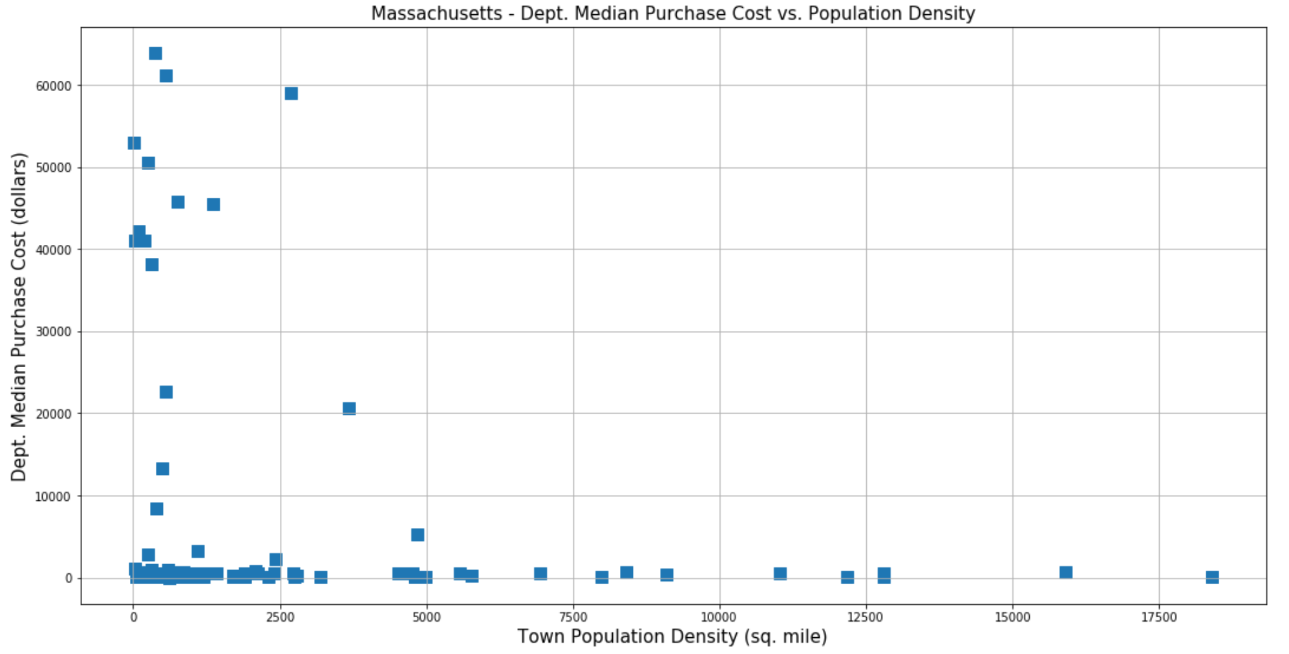

The figure above shows that a given Massachusetts town with low population density tended to have higher median purchase amount than its higher population density counterparts. The high median purchase amounts are almost exclusively within 0-1500 people/ sq. mile with some outliers. Interestingly, both race and education do not seem to have any relationship with median purchase cost or average cost; it is largely a flat line between the two stated variables.

To help dive a little further into department purchasing patterns, the town’s “per capita” income was plotted up against the department’s total purchase cost in dollars.

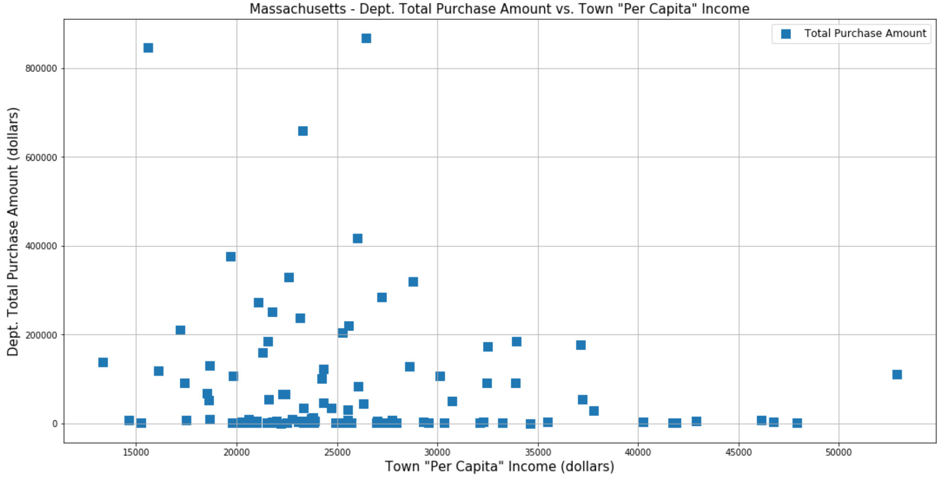

The figure above shows per capita income for each town versus its department’s total dollar cost of all purchases. The plot shows that lower per capita income tended to have higher total dollar purchase cost. The graph almost seems to follow a skewed normal distribution with the highest total purchase amount centered around the 20,000 - 25,000 dollars per capita income.

The figure below shows per capita income versus the population density for each town in Massachusetts. The figure seems to show that towns with per capita income between 20,000 - 25,000 dollars tended to have low population density within 1500 people per. Sq. mile with very few outliers.

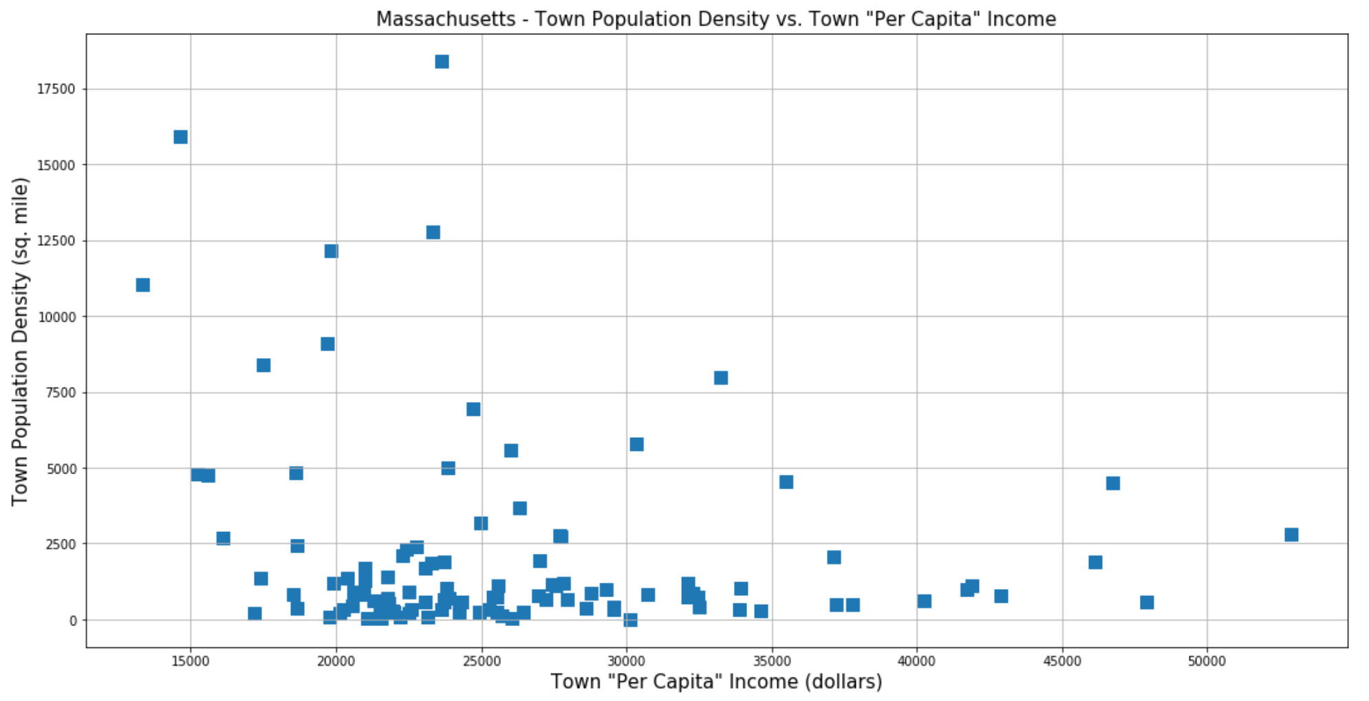

Going forward, those towns that had abnormally large median purchases and large total purchase amounts will be pooled together and a deeper dive will be taken to find out what is similar within this smaller population.

Preliminary analysis of question 3 is done in Massachusetts by visualizing the amount of equipment purchased before and after the World Trade Center attacks (September 11, 2001), and the Boston Marathon Bombing (April 15, 2013). This initial exploration is done by segregating the populations on each side of these dates to see if big purchases are done before or after the events.

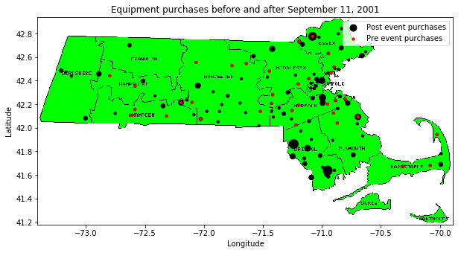

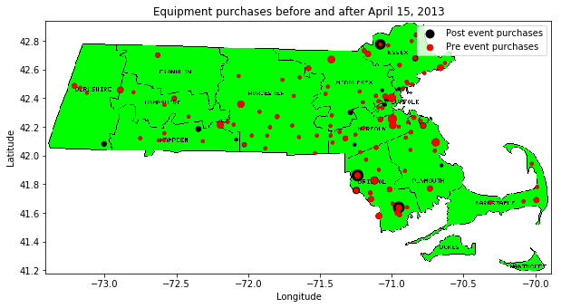

Further analysis will zoom out to the county level and shows when big purchases were made by each county. There is a large and sustained spike in purchases across the whole state after 2011.

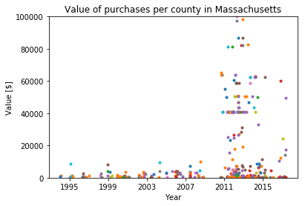

No county labels are given to the colors as this plot is demonstrating a general trend across the state. This increase of weapon acquisitions post 2011 will be analyzed in Massachusetts to determine the cause. It will also be looked for across other states to determine if other states exhibit a similar trend. This increase in equipment purchases does not correspond to 9/11 or the Boston Marathon Bombing which is contrary to the initial intuition.

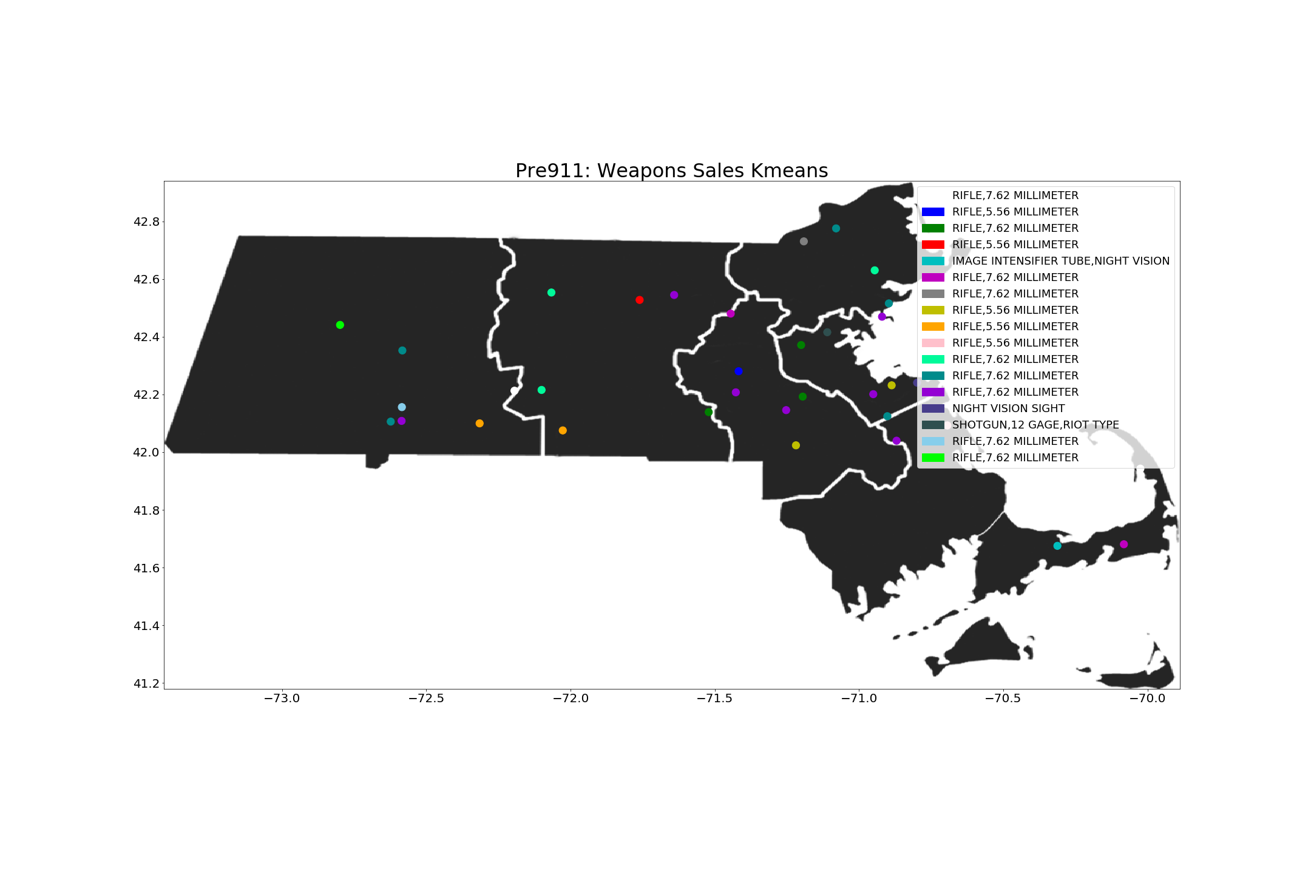

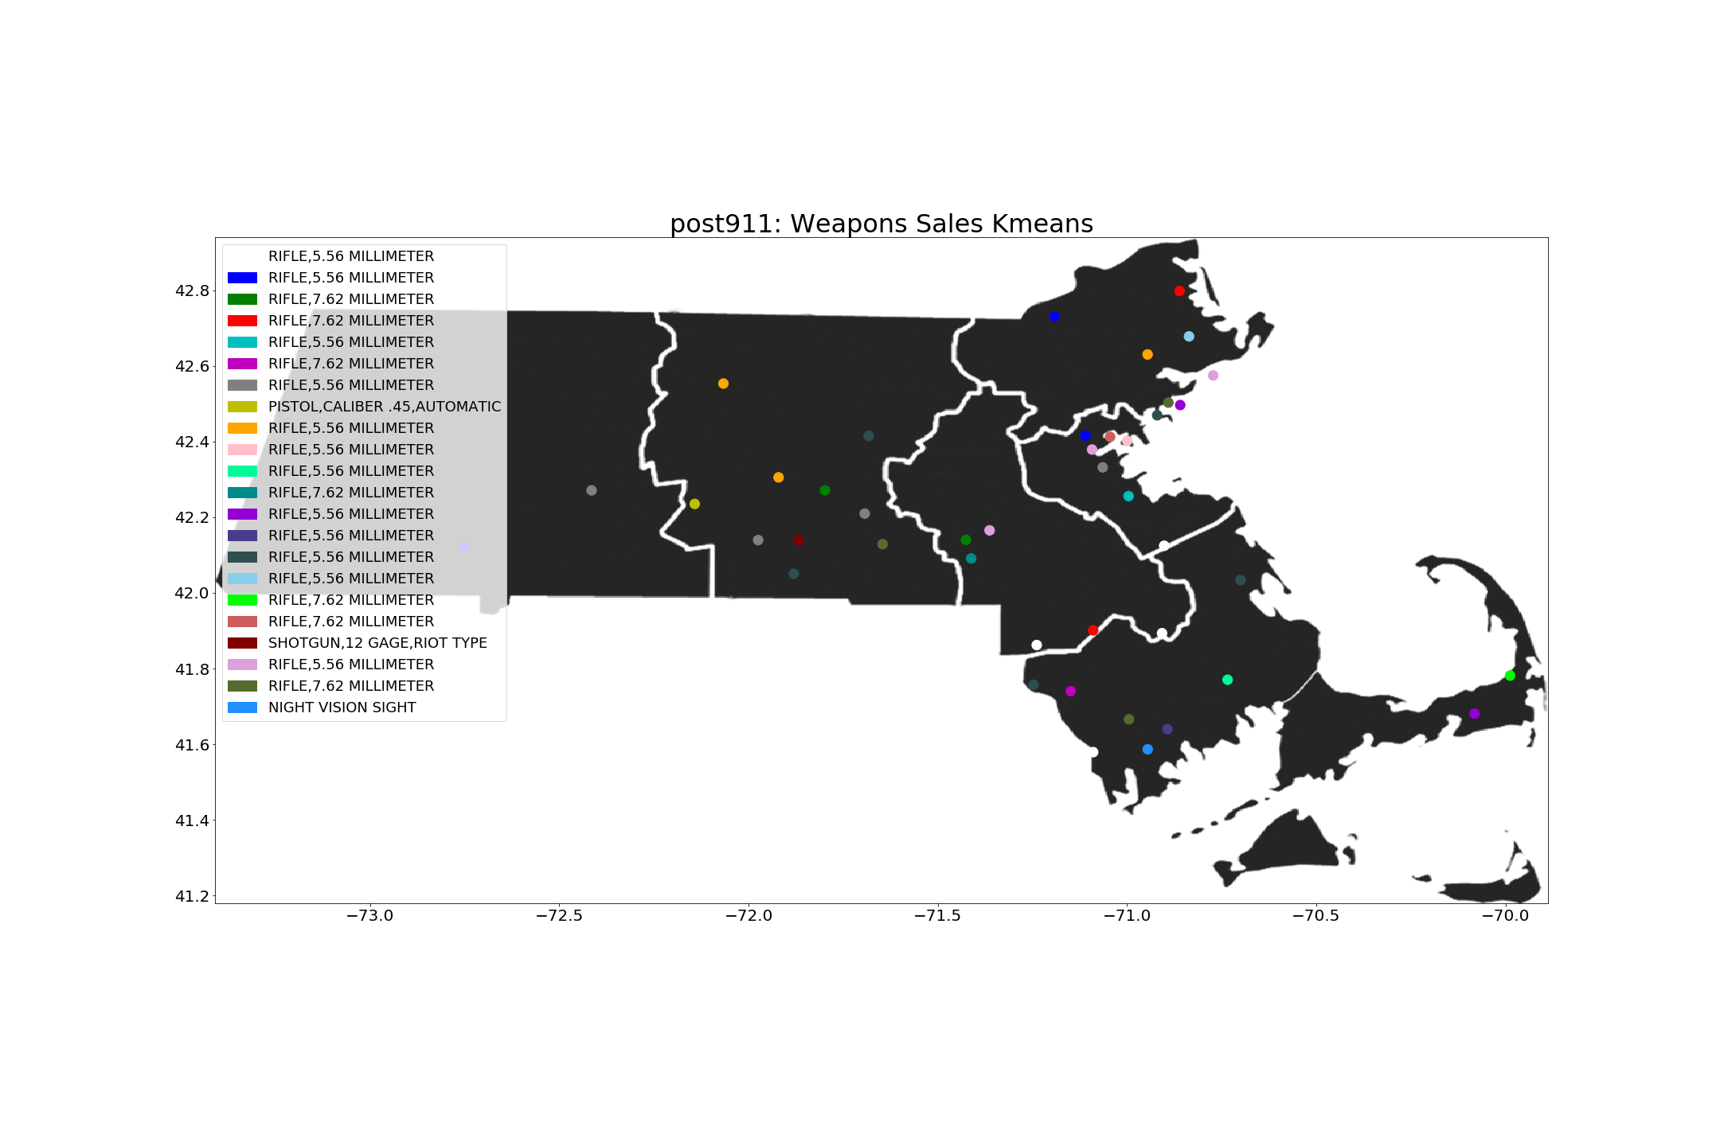

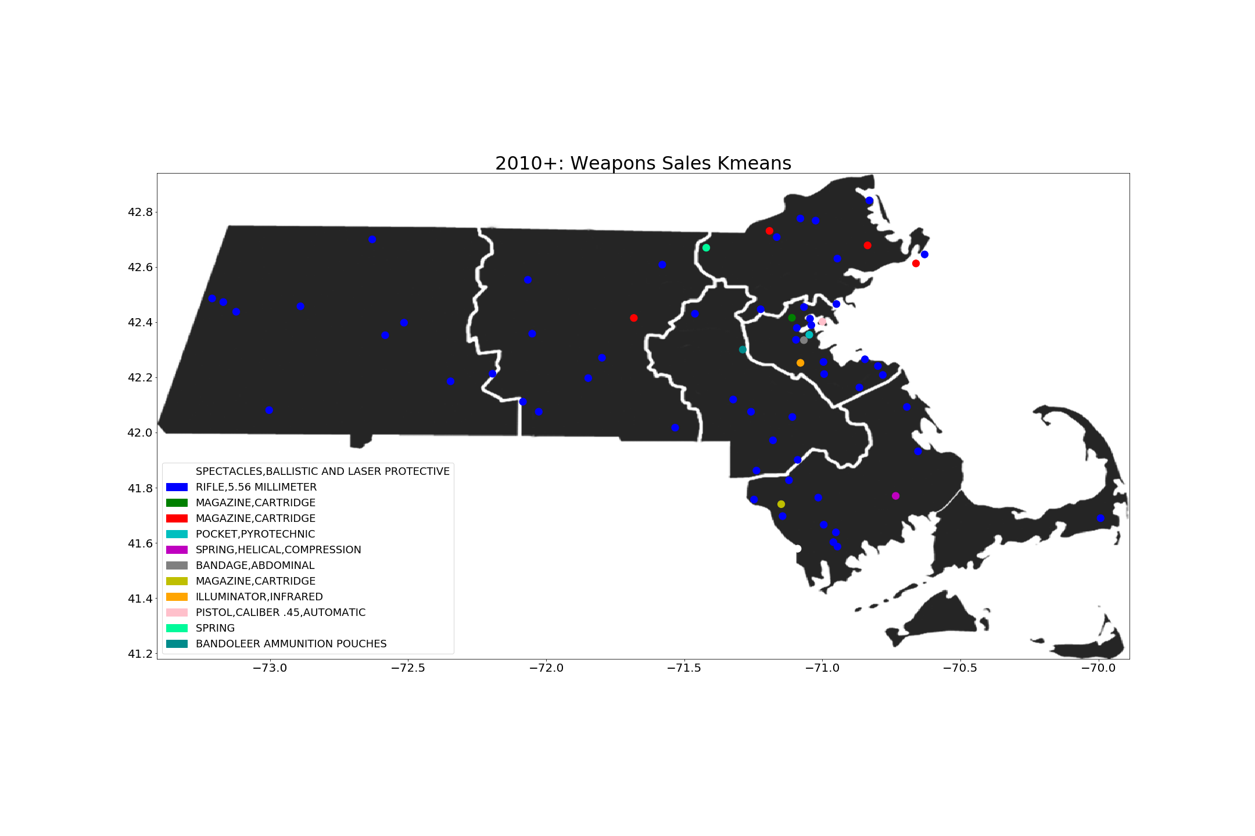

To answer question 4, preliminary analysis began by creating vectors that quantify which equipment is purchased by which police station. The K Means clustering algorithm is then used on the raw data to determine which LEAs are similar to each other in regards to the type of equipment acquired. As a initial study the data was separated into pre 9/11, post 9/11, and 2010+ data. It currently shows that pre and post 9/11 majority of sales were for rifles both 7.62 and 5.56 millimeter. Post 9/11 it shows an increase in military arms sale and a concentration in certain areas such as Boston. Come 2010+ there is much more arms sale compare to previous years and the top types of arms begin to diversify. Refinement on this study will need to be done in order to better understand the data. Rescaling of the data and reducing the feature vector to certain arms needs to be conducted to better understand and visualize the arm sales trends.

Parallel to this, an analysis into the demographics within each town is completed, to determine what the differences between each town are, and how that drives what equipment, and how much money, each LEA spends. The initial analysis has all the data in one group, however, the acquisition of military equipment occurs over quite a long time period. Further analysis will break down the data into various time periods. Another avenue for grouping, would be to group the time periods every 10 years, which aligns with the time periods of census data. 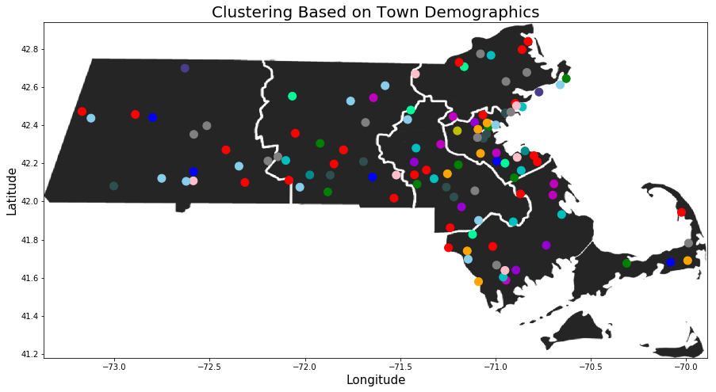

The preliminary analysis clusters are based on the wealth and race distributions of counties in MA, but further analysis will look for groupings by larger geographic locations. From the plot above, all towns in each color category have similar levels of wealth and race distribution. Further refinement, such as an analysis into regions of the United States, will be done to check if different geographic locations relative to the country have any effect on the groupings. Finally, analysis into the type and size of the municipality will be done to complement the current analysis.